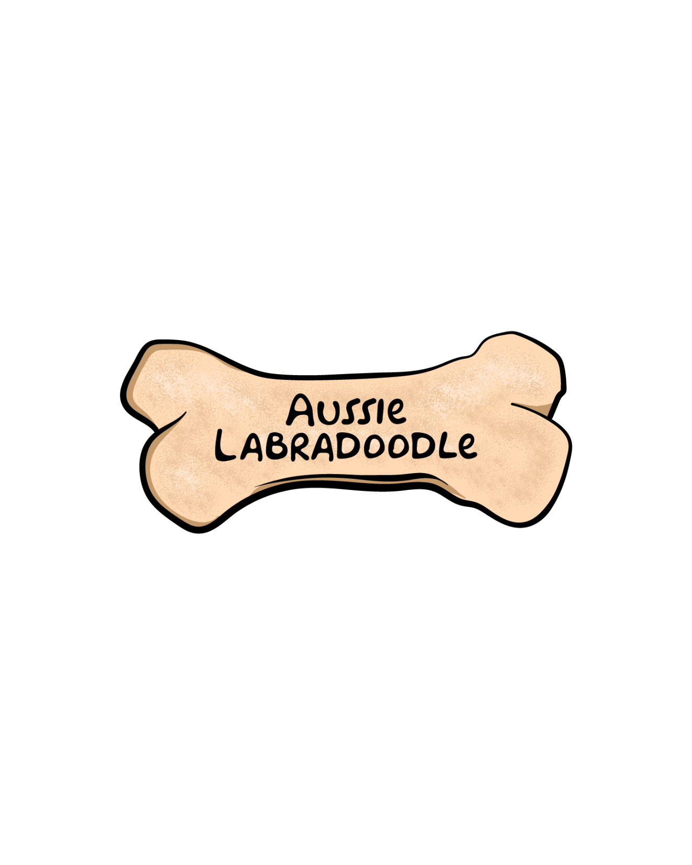**SALES CONTRACT AND**

**HEALTH GUARANTEE**

**SELLER:**

Kari Lambert, Aussie Labradoodle

12677 Tollgate Road, Pickerington, Ohio 43147

614-829-5303, 614-203-5623

[aussiedoodle@earthlink.net](mailto:aussiedoodle@earthlink.net)

[info@aussielabradoodle.com](mailto:info@aussielabradoodle.com)

**PURCHASER**:

Name:_______________________________________________________

Address:_____________________________________________________

____________________________________________________________

Contact Phone Numbers:________________________________________

Email address:________________________________________________

**DESCRIPTION OF DOG**:

Parents:______________ __________

Description (color, coat):____________________________________

Microchip number:_________________________________________

**DETAILS OF HEALTH GUARANTEE**:

Aussie Labradoodle (herein known as AL) guarantees that puppy is believed to be healthy at the time of sale and has received appropriate vaccinations and dewormings for age. Purchaser has ten days from the time of receipt to have dog examined by a veterinarian. Proof of examination must be provided to AL within allotted time.

If puppy is found to have an hereditary defect which impacts clinically on its quality of life, excluding dental work, by the age of two years, as certified by a veterinarian at Purchaser’s expense, AL has the right to require a second opinion from a veterinarian of AL’s choosing at AL’s expense.

A warranty for Hip Dysplasia is provided for two years after the date of sale. This warranty will be terminated should the dog be allowed to become overweight, or should developing joints become over-stressed at any point during the warranty period. Should the dog be found to have Hip Dysplasia within the first two years, the Purchaser must provide AL with proof in the form of documentation from OFA or Penn HIP.

The warranty does not include viral illnesses, infections, improper bites, umbilical hernias, hypoglycemia, giardia or coccidosis. It also does not include any illness due to the ingestion of foreign objects, food, chemicals or physical injury. If the dog is euthanized or in any way disposed of without a second opinion from the seller’s preferred veterinarian, the buyer waives all rights to a replacement puppy or to any financial payment as compensation.

**PURCHASER/ADOPTER AGREES TO**:

1. House their puppy indoors.
2. Feed their puppy only a premium quality food, and keep puppy at a healthy weight.
3. Make and keep appropriate veterinary appointments for their puppy and keep all immunizations current.
4. Provide basic obedience training for their puppy within the first year of owning their dog.
5. Postpone strenuous, repetitive exercise during growth period of puppy, the first two years of age.

**TERMS OF HEALTH GUARANTEE**:

AL offers a two-year health guarantee. This does NOT cover the following: mistreatment of puppy, injury, accidents, poisoning, etc., overweight or underweight dog, or if dog has been used in agility, running, jumping, or over-exercised during their growth period of two years. It does NOT cover trauma-related or environmental factors that have affected the dog adversely. Guarantee applies only to original purchaser of dog.

Purchaser must supply to AL a veterinarian’s report showing possible hereditary defects within seven days of making the first complaint to AL. Their veterinarian must forward a copy of all available reports to AL for review. (*It is imperative that microchip is scanned and documented on all veterinary reports*.)

In the case of a hereditary defect clinically impacting dog’s quality of life, the following will be offered, as determined by AL:

1. AL will replace with puppy/dog of equal value. AL has 12 months replace puppy, depending upon what is available.
2. If customer wants to keep AL dog, AL will reimburse Purchaser up to and not exceeding half of the purchase price of the dog, not including sales tax or shipping.
3. For shipping, Purchaser bears all costs.

**REHOMING**:

Purchaser agrees that if at any time Purchaser wishes to rehome, destroy or give away dog, they will give AL every opportunity to help in rehoming the dog.

*The warranty set forth in this contract is the sole warranty and is given in lieu of any and all other warranties, expressed or implied. The Purchaser’s sole remedy is under the warranty provision of this contract and the Purchaser disclaims and will not be liable for any other damages including consequential damages, property damage, emotional distress, loss of use, business interruption, or veterinary fees unless specifically set forth in this warranty provision. The contract sets forth the entire agreement between AL and Purchaser and any inconsistent oral terms have no effect on this contract. If there is any dispute or litigation between the seller and buyer, the prevailing party will be entitled to reasonable attorney’s fees and costs.

**I, the purchaser of the dog described on this document do hereby declare that I have read and do fully understand and agree with the terms of this contract.**

PURCHASER’S SIGNATURE:________________________________

DATE:___________________________________________________

SELLER’S SIGNATURE:__________________________________

DATE:___________________________________________________

PURCHASE PRICE OF DOG:________________________________

\**This contract is transferable in a rehome situation only if the new owner is willing to sign and abide by a new contract with Aussie Labradoodle, and Aussie Labradoodle approves the transfer*.