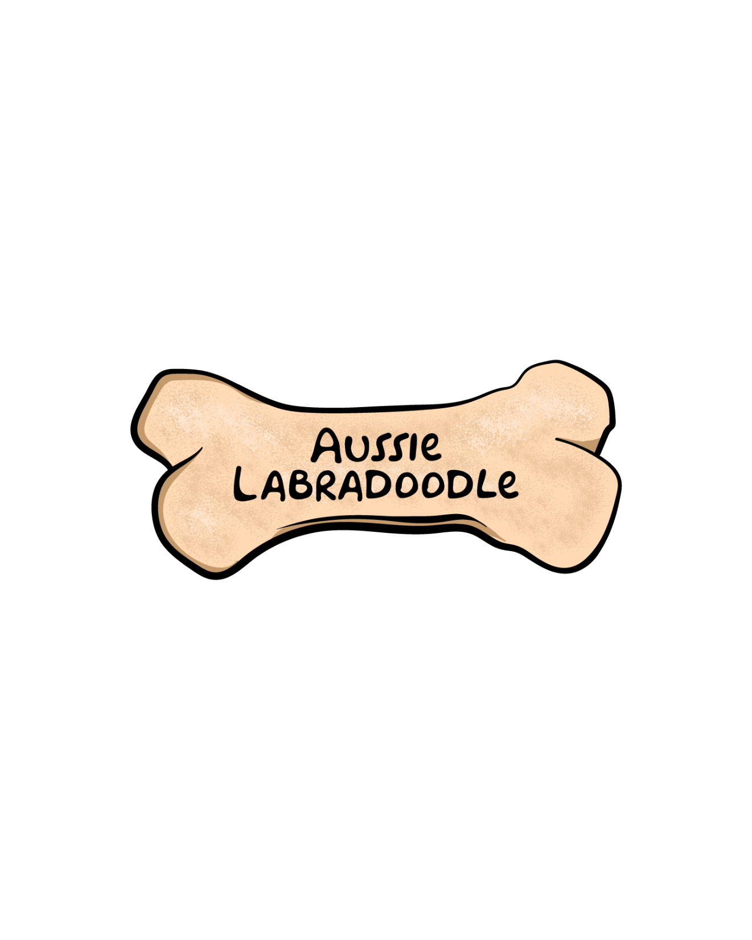

**SPAY/NEUTER CONTRACT**

**SELLER:**

Kari Lambert

Aussie Labradoodle

12677 Tollgate Road, Pickerington, Ohio 43147

614-829-5303, 614-203-5623

[aussiedoodle@earthlink.net](mailto:aussiedoodle@earthlink.net)

[info@aussielabradoodle.com](mailto:info@aussielabradoodle.com)

**PURCHASER/ADOPTER**:

Name:_______________________________________________________

Address:_____________________________________________________

____________________________________________________________

Contact Phone Numbers:________________________________________

Email address:

**DESCRIPTION OF DOG**:

Parents:___________________________________________________

Date of Birth:______________________________________________

Description (color, coat):_____________________________________

Microchip number:__________________________________________

*\*Permanent ownership of this dog is contingent upon your compliance with this Addendum. Puppy is sold as a companion pet only, NOT for BREEDING purposes. Breeding rights do not convey with this puppy.*

Aussie Labradoodle (herein known as AL) must receive proof of the spay/neuter of your Aussie Labradoodle puppy by **ten months of age** at Purchaser’s expense. It is the responsibility of the Purchaser, not the veterinarian, to ensure AL has received verification that the surgery has been performed. *It is imperative that microchip be scanned and recorded by veterinarian on all documentation*.

By signing this document, the Purchaser agrees to have this dog spayed/neutered in the time period agreed to in this document. Purchaser also agrees that this dog will not produce a litter of puppies, either as purposely bred or by accidental breeding.

Failure to comply with this agreement by the date indicated, unless otherwise agreed to in writing, will be considered a breach of contract, in which case the Purchaser will be liable for $7,500, which is the balance for the price of a breeding Australian Labradoodle.

If necessary, legal action will be taken to collect damages and Purchaser will be responsible for all legal fees incurred by Aussie Labradoodle related to the enforcement of this legal contract. The Purchaser also agrees that failure to comply will void the Health Guarantee.

**I, the purchaser of the dog described on this document do hereby declare that I have read and do fully understand and agree with the terms of this contract.**

PURCHASER’S SIGNATURE:________________________________

DATE:___________________________________________________

SELLER’S SIGNATURE:__________________________________

DATE:___________________________________________________